Question: Write a SQL query to find the top 10 content creators in 2018 that have the highest average donations per viewer.

My Solution:

One way to approach this problem is to break it down into more simple parts. According to the question, we need to look up content creators in 2018 only. Then we need to write a script to calculate the average donations per view, since the database only contains donation values and numbers of views in separate tables. Finally, we need to rank these and sort from highest to lowest to see the top 10.

Step 1: Total number of viewers by session_id

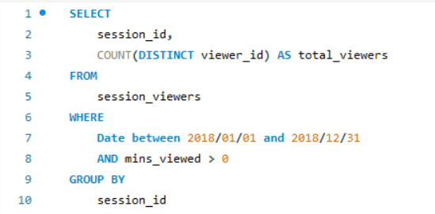

Step 2: Total donations by session_id

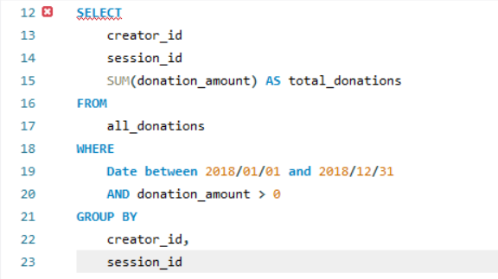

Step 3: Calculate Donations per viewer by joining the above queries

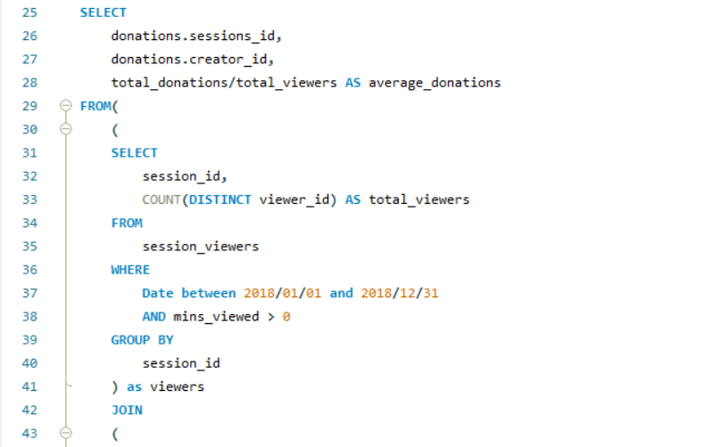 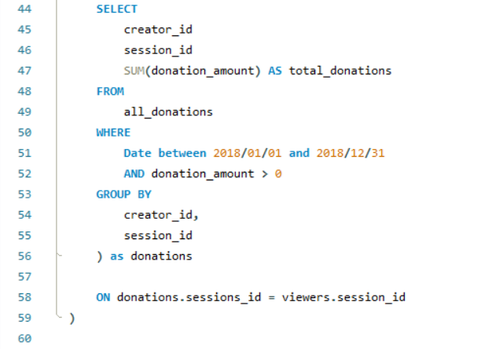

Step 4: Now we can sort the query and return the top ten results

